Terms of reference – advocacy working group

# INTRODUCTION

The origins of advocacy date back to ancient Rome and Greece when well-established orators would perform as advocates or wrote orations specifically for pleading someone’s cause. In the contemporary world, advocacy refers to a process to improve or change policies and practices, reform institutions, alter power relations, change attitudes and behaviours and bring about a broader and sustainable impact.

In development cooperation, interventions are influenced by political, economic and social frameworks at all levels. Not all political, economic and social frameworks are supportive; they can also obstruct sustainable, scalable and inclusive development impacts. Policy processes do not only determine the context in which projects’ primary stakeholders have to make a living and in which we and our development partners have to work, but also the prospects of human development as such. A successful advocacy intervention is all about bringing a positive impact on the lives of primary stakeholders.

The Advocacy Working Group held discussions in Montenegro (May 2018) to gather existing experiences of advocacy work from different projects. It also looked into to what extent the advocacy initiatives were successful or limited in achieving their goals and explored ideas of improving their effectiveness (forward-looking solutions). The regional advocacy workshop held in Durres (September 2018) contributed to bringing together different projects and work on concrete cases of advocacy initiatives. The Working Group heavily builds on these two events (as well as the advocacy strategy of Helvetas)[1] and takes forward the discussion to achieve the objectives stated below.

***What It Is***

At its simplest, advocacy seeks to change or improve rules, public institutions, plans, programmes, projects and actions, budgets and public investments. It is a deliberate process of influencing decisions within political, economic and social systems and institutions with the aim of making policies and processes more just, inclusive and pro-poor, including through public action.

Advocacy can be informal or confidential talks with decision makers or roundtables with selected participants (insider route) to methods that seek to expose the target audience to a broader public (outsider route). The latter can include petitions and open letters, public hearings, or even mass events. Lobbying is a form of advocacy where experts in their particular field (‘lobbyists’) directly approach legislators on a particular policy issue. It often builds on previous, more public advocacy campaigns – broadly concerted, mostly public effort to influence a particular decision-making process. Effective advocacy usually combines different approaches in a complementary manner.

Most importantly, successful advocacy interventions take into account the advocacy ecosystem. This means the interventions should take into account the capacities and interests of a range of suitable partners. By having a good analysis of the advocacy ecosystem, projects are also able to identify root causes and not symptoms.

***What We’ll Do***

The Advocacy Working Group within Helvetas’ learning agenda will have the key objective of bringing together different staff of projects to critically discuss advocacy cases, refine/improve them, and document and disseminate key lessons to a wider audience. To start with, the Working Group will use cases that were the focus of the recent Advocacy Workshop in Durres (Albania). The Working Group continually explore other cases whenever this is relevant. In the process, the Working Group will structure discussions around three underlying steps of designing and implementing advocacy initiatives/cases:

1. Improving the lives of disadvantaged people/citizens requires stimulating improvement or change in policies or regulations and expanding access to services. Primary stakeholders (people/citizens) always exist within a context in which they manage their livelihood or day-to-day affairs. **Better understanding the advocacy ecosystem** can help projects to increase their impact through identifying root causes for the inadequacy or absence of policies or regulations, as well as the incentives and capacities of actors – public, private and civil societies.
2. The cases for discussions will focus on how to **design effective advocacy strategy**. This concerns understanding the change that an advocacy initiative aims to see (theory of change), developing communication strategies and assessing resources. For example, the members of the Working Group will look into how to formulate a simple problem and solution, develop a clear motivation and legitimacy, gather political support and form alliances, and understand and build on momentum.
3. Advocacy works but it also fails. As no discussion of advocacy processes would be complete without measuring successes and failures of advocacy initiatives, the Working Group will stimulate discussion and sharing of experiences on **innovative ways of assessing and communicating advocacy**. This will be based on research for understanding that policy change is never linear and usually takes a lot of time. Often, measuring advocacy initiatives will involve (a) *definition:* understanding of the target groups and other stakeholders, (b) *behaviour:* assessing changes in partners, allies and primary stakeholders, (c) *engagement:* examining to what extent concrete steps are taken to address an issue, (d) policy: assessing the changes or improvements and (e) *practice:* evaluating if advocacy initiatives lead to improvements to the primary stakeholders. The Working Group will review this process and consolidate it based on concrete experiences.

# OBJECTIVES OF THE WORKING GROUP

The Advocacy Working Group aims to:

* Bring together staff of different projects who want to further explore the topic of advocacy and apply new *frameworks and tools* in their work
* Refine *tools and intervention methodologies* in light of a shared understanding of advocacy as a deliberate process
* *Exchange and learn* among projects on designing, facilitating, communicating and measuring advocacy processes in development cooperation
* Identify, analyse and publish *case studies* related to advocacy in the context of development cooperation
* Share learning within and outside Helvetas by regularly sharing innovative practices and failures (“oops moments”).

# MEMBERSHIP & LEAD

* The members of the Working Group comprise staff of projects (both management and technical) in Eastern Europe, other project staff, representative of the Eastern Europe Unit (EEU) (Zenebe Uraguchi), other Helvetas staff (Bernd, Jens), as well as (at a later stage) partners.
* The lead of the Working Group is with Valbona Karakaçi (Project Advisor, BtF). Members of the Working Group are meant to take on special roles and tasks (For the work plan, see annex 1).

Annex 2: Highlights of discussion points in the Advocacy Workshop (Durres, September 2018)

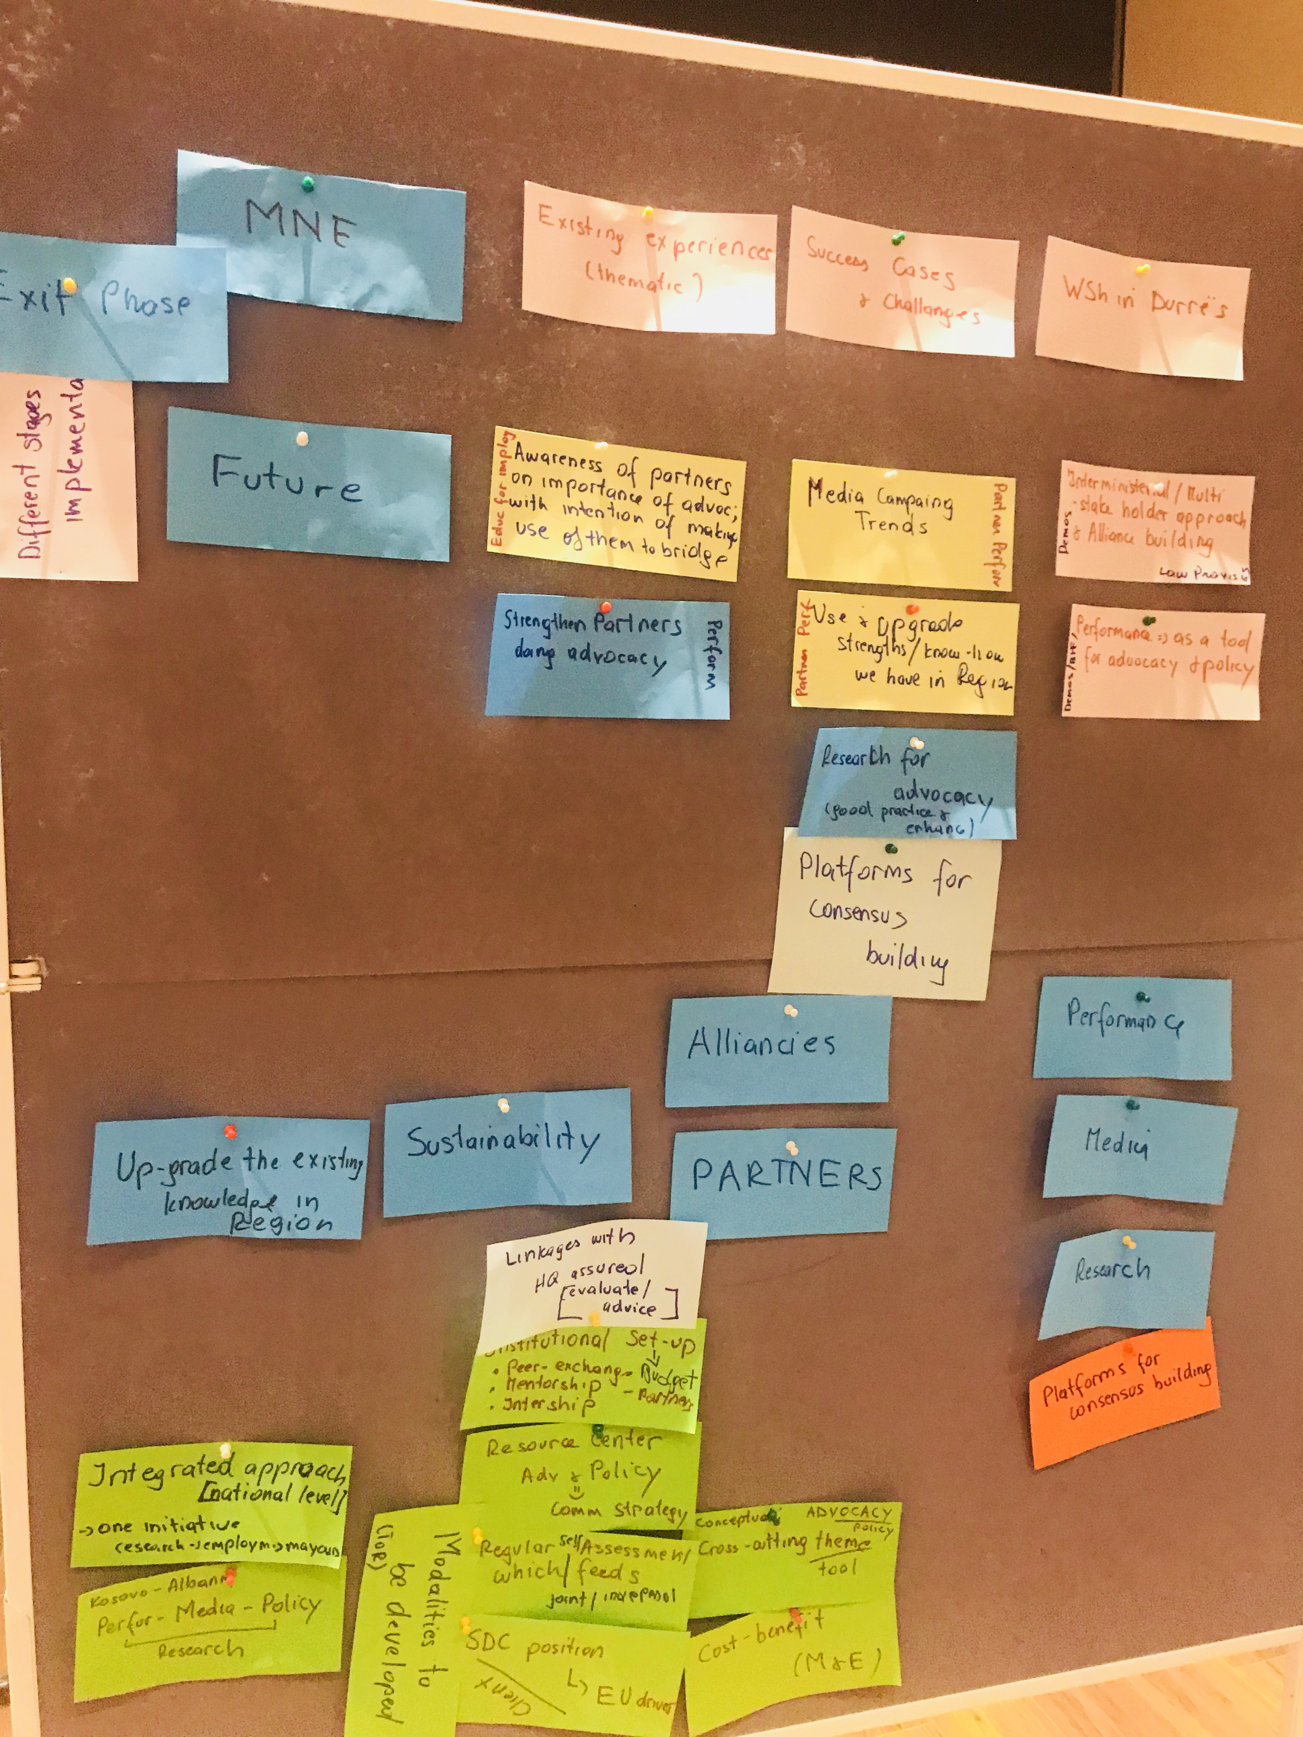

1. See a short version on “Advocacy Concept”: <https://www.helvetas.org/Publications-PDFs/concept_advocacyconcept_en.pdf>